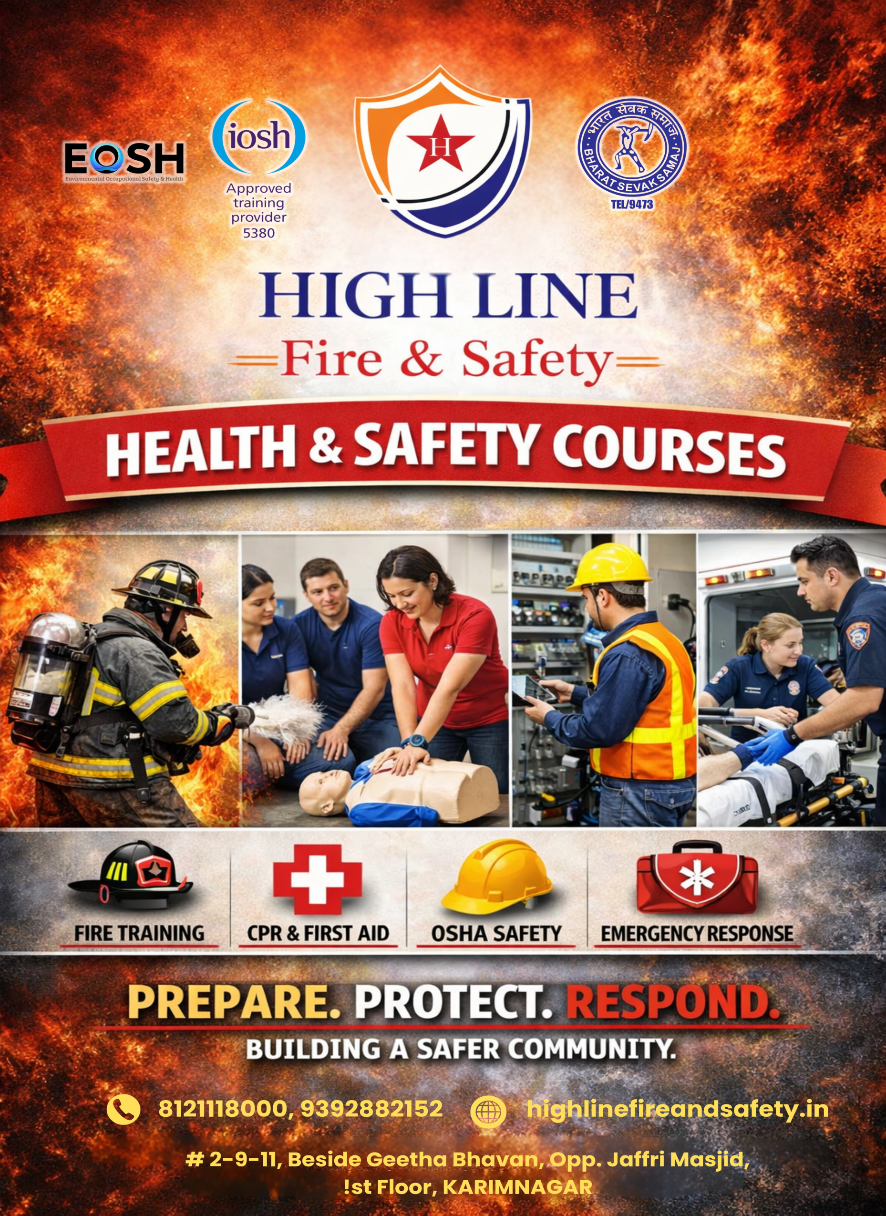

Advance Diploma in Health, Safety & Environment (ADHSE):
We the Advance Diploma in Health, Safety & Environment (HSE) to support you in building a confident and successful career in the safety profession. In this program, we guide you through the core principles of occupational health, workplace safety, and environmental management, helping you understand not just the rules—but the reasons behind them.
We focus on real-world safety practices used across construction sites, industries, and high-risk work environments. You will learn how to identify workplace hazards, assess risks, develop control measures, and implement safety systems that protect people, property, and the environment.
Through practical training, case studies, and industry-relevant guidance, we prepare you to meet professional safety responsibilities with confidence. Our goal is to equip you with the knowledge, skills, and mindset needed to promote a strong safety culture and make a real difference in workplaces.

Eligibility :
- 10th or above
- Freshers or working professionals
- No prior experience required

Course Duration :
- 1 year

Topics Covered :
- Management of Health & Safety
- Safeguarding People’s Safety in the Workplace
- Safeguarding People’s Health in the Workplace

Training Method :
Classroom Training and Online Classes

Job Roles :
- Fire Safety Officer
- Fire Marshal
- Emergency Response Staff
- Safety Officer

Work Areas :

Factories, malls, hospitals, construction sites, oil & gas plants

Diploma in Fire Safety:
The Diploma in Fire Safety is designed to provide learners with essential knowledge and practical skills to prevent, control, and respond to fire emergencies in the workplace. Fires can occur in any environment, including offices, factories, construction sites, and industrial plants, and proper training is necessary to minimize risks and protect lives and property. This course teaches students about the causes of fire, types of fire extinguishers, alarm systems, evacuation procedures, and emergency response techniques. With a strong focus on safety awareness and hands-on practice, learners become confident in handling fire-related incidents. This diploma is ideal for those who wish to build a career as a fire safety officer, fire marshal, or emergency response professional.

Eligibility :
- 10th or above
- Freshers or working professionals
- No prior experience required

Course Duration :
- 6 months

Topics Covered :
- Fundamentals of Fire Science
- Fire Prevention & Protection
- Firefighting Equipment & Techniques
- Emergency Planning & Evacuation
- Fire Risk Assessment
- Industrial Fire Safety
- Legal Framework & Standards
- Practical Training & Drills

Training Method :
Classroom Training and Online classes

Job Roles :
- Fire Safety Officer
- Fire Marshal
- Emergency Response Staff
- Safety Officer

Work Areas :
Factories, malls, hospitals, construction sites, oil & gas plants

Diploma in Construction Safety:
The Construction Safety course focuses on promoting safe working practices in construction environments, where the risk of accidents is often higher due to heavy machinery, heights, and moving equipment. This program helps learners understand common construction hazards and teaches them how to follow safety rules, use personal protective equipment correctly, and maintain a secure worksite. Students gain practical knowledge in accident prevention, site inspections, and safety procedures that reduce injuries and ensure smooth project operations. This course is highly beneficial for individuals planning to work on construction sites as safety officers, supervisors, or skilled workers who want to prioritize safety at work.

Duration :
- 1–4 weeks.

Safety Topics Covered :
- Introduction to Construction Safety
- Construction Safety Management
- Hazard Identification & Risk Assessment
- Site Safety Practices
- Work at Height Safety
- Lifting Operations & Equipment Safety
- Excavation & Confined Space Safety
- Emergency Preparedness & Incident Investigation
- Legal Requirements & Standards
- Practical Training & Site Visits

Job Roles :
- Construction Safety Officer, Site Supervisor, Safety Assistant.

Certificate in Scaffolding Safety:
The Scaffolding Safety course is specially developed to train learners in safe working methods while using scaffolding systems at heights. Since falls from height are one of the leading causes of serious injuries in construction work, proper knowledge of scaffolding safety is very important. This course teaches how to erect, inspect, maintain, and safely use scaffolding structures, along with the correct use of harnesses and fall protection equipment. Learners are trained to recognize unsafe conditions and take preventive measures to avoid accidents. It is an excellent choice for construction workers, supervisors, and safety personnel who regularly work at elevated areas.

Duration :
- 1–2 weeks.

Safety Techniques Covered :
- Introduction to Scaffolding Safety
- Types and Components of Scaffolding
- Scaffold Erection and Dismantling
- Load Capacity & Stability
- Scaffold Inspection & Maintenance
- Practical Session

Job Roles :
- Scaffolding Inspector, Supervisor, Height Worker.

Certificate in Risk Assessment:
The Risk Assessment course provides learners with the knowledge and skills needed to identify workplace hazards and evaluate potential risks before accidents occur. Every workplace contains certain dangers, whether it is machinery, chemicals, electricity, or environmental conditions. This course teaches students how to carefully observe work areas, analyze risks, and implement effective control measures to ensure a safer environment. By learning how to plan preventive actions and improve safety standards, learners contribute to reducing injuries and increasing productivity. Risk assessment skills are essential for safety officers, supervisors, and managers in all industries.

Duration :
- 2–5 days.

Key Topics Covered :
- Introduction to Risk Assessment
- Hazard Identification
- Risk Evaluation
- Control Measures
- Recording & Reviewing
- Practical Session

Job Roles :
- Safety Assistant, Supervisor, HSE Staff.

Certificate in Basic First Aid:
The Basic First Aid course is a practical training program that prepares learners to provide immediate medical assistance during emergencies until professional help arrives. Accidents and sudden illnesses can happen at any time, and quick action can often save lives. This course teaches important skills such as CPR, controlling bleeding, treating burns, managing fractures, and responding to choking or fainting situations. With hands-on practice and real-life examples, learners gain the confidence to handle emergencies calmly and responsibly. First aid knowledge is valuable not only in workplaces but also in everyday life, making it an essential skill for everyone.

Duration :
- 1–3 days.

Skills You Will Learn :
- Introduction to First Aid
- Emergency Scene Management
- Cardiopulmonary Resuscitation (CPR)
- Automated External Defibrillator (AED)
- First Aid for Common Emergencies
- Medical Emergencies

Career Benefits :
- Useful for all workplaces and everyday life situations.

Certificate in Work Permit Receiver (WPR):
The Work Permit Receiver course is designed to train learners in the safe management of high-risk jobs through the permit-to-work system commonly used in industries such as oil and gas, power plants, and heavy manufacturing. In these environments, tasks like welding, electrical maintenance, or confined space work require official authorization to ensure all safety precautions are in place. This course teaches learners how to understand permit procedures, identify hazards, follow safety guidelines, and coordinate with teams before starting any task. By developing strong safety awareness and responsibility, learners are better prepared to manage risky operations safely and efficiently.

Duration :
- 2–5 days.

Topics Covered :
- Introduction to Work Permits
- Types of Work Permits
- Permit Receiver Responsibilities
- Hazard Identification & Risk Control
- Permit Compliance During Work
- Closing a Work Permit

Job Roles :
- Work Permit Receiver, Plant Operator, Safety Coordinator.

Diploma Industrial Safety:
The Industrial Safety course is designed to train learners in maintaining safe working conditions in factories, construction sites, warehouses, and manufacturing industries.
It focuses on preventing workplace accidents, reducing hazards, and ensuring compliance with safety rules and regulations.
Learners develop knowledge in hazard identification; risk control, fire prevention, and worker protection, helping organizations create a safe and productive work environment.

Duration :
• Certificate – 3 to 6 months
• Diploma – 1 year
• Advanced / PG Diploma – 1 to 2 years

Topics Covered :
• Safety Management System (SMS)
• Hazard Identification & Risk Assessment (HIRA/JSA)
• Fire Prevention & Firefighting
• Construction Safety
• Electrical Safety
• PPE & Work Permit System
• First Aid
• Accident Investigation
• Industrial Hygiene
• Safety Laws & Regulations

Job Roles :
• Safety Officer
• HSE Officer
• Site Safety Supervisor
• Safety Inspector
• EHS Executive
• Fire & Safety Technician

Diploma in Oil & Gas Safety:
The Oil & Gas Safety course is a specialized safety training program focused on high-risk operations in refineries, offshore rigs, drilling sites, pipelines, and petrochemical plants.
It prepares learners to manage explosions, toxic gases, confined spaces, and process hazards while ensuring strict safety compliance.
This field requires advanced safety skills and offers higher salary and overseas opportunities.

Duration :
• Certificate – 3 to 6 months
• Diploma – 1 year
• PG Diploma / Advanced – 1 to 2 years

Topics Covered :
• Process Safety Management (PSM)
• Permit-to-Work System
• HAZOP & HAZID Studies
• Confined Space Safety
• Fire & Explosion Prevention
• Gas Detection & Monitoring
• Chemical Handling Safety
• Emergency & Disaster Management
• Lockout–Tagout (LOTO)
• Offshore & Rig Safety

Job Roles :
• HSE Officer (Oil & Gas)
• Process Safety Engineer
• Rig Safety Officer
• Offshore Safety Supervisor
• Fire & Rescue Officer
• Safety Auditor
• Loss Prevention Engineer

EOSH (Environment, Occupational Safety & Health):
Our EOSH program is designed to provide a strong understanding of workplace safety, occupational health, and environmental protection. This course helps learners build the knowledge and awareness required to meet modern safety and compliance requirements across various industries. The program covers key areas such as occupational safety practices, fire safety fundamentals, hazard identification, risk assessment, workplace health and hygiene, and environmental management. Special emphasis is placed on accident prevention, emergency preparedness, and responsible work practices.
With a practical and preventive approach, the EOSH course prepares learners to confidently support safe, healthy, and compliant work environments. It is well suited for students and professionals looking to strengthen their safety knowledge and expand their career opportunities.

Eligibility :
- 10th / 12th pass or above
- Freshers and working professionals
- No experience required

Course Duration :
- 1–4 weeks (depending on level)

Topics Covered :
- Environmental safety

Training Method :
Classroom + practical demonstrations

Certification :
EOSH Course Completion Certificate

Job Roles :
- HSE Assistant
- Environmental Safety Officer
- Safety Supervisor
- Site Safety Staff

Work Areas :
Factories, construction, industries, environmental projects.

OSHA (Occupational Safety and Health Administration):
We offer OSHA-based training to help you understand how workplace safety standards are applied in real working environments. Through this course, we explain the importance of identifying hazards, controlling risks, and following safe work practices to prevent accidents and injuries. In this program, we guide you through key topics such as workplace safety rules, hazard identification, risk control measures, fire safety basics, use of PPE, and emergency response. We also help you understand your role and responsibility in maintaining a safe work environment. Our OSHA training focuses on practical understanding and safety awareness, making it suitable for students, supervisors, and working professionals who want to improve safety knowledge and work confidently in compliance-driven environments.

Eligibility :
- 10th / 12th pass or above
- Freshers or workers
- No prior experience required

Course Duration :
- OSHA 10 Hours – 2 days
- OSHA 30 Hours – 3–4 days

Topics Covered :
- Workplace hazards
- PPE usage
- Fall protection
- Electrical safety
- Fire prevention
- Safety regulations

Training Method :
Classroom training + practical examples + case studies

Certification :
OSHA Authorized Training Certificate/Card

Job Roles :
- Safety Assistant
- Site Safety Worker
- Construction Worker
- Safety Supervisor

Work Areas :
Construction sites, factories, warehouses, oil & gas.

IOSH (Institution of Occupational Safety and Health):
IOSH is a globally recognized professional body that focuses on improving health and safety standards in workplaces. IOSH courses are designed to build safety awareness and promote safe behavior at work.
We offer IOSH-based training to help you understand how everyday safety practices can prevent accidents and injuries. Through this course, we explain the importance of identifying hazards, assessing risks, and following safe work practices in a simple and practical way.
In this program, we guide you through key topics such as workplace safety responsibilities, hazard awareness, basic risk control measures, fire safety awareness, and safe working habits. The focus is on understanding safety from a practical point of view rather than complex rules.
Our IOSH training is ideal for students, supervisors, and working professionals who want to improve safety awareness and contribute to a safer working environment.

Eligibility :
12th pass or above, Supervisors, team leaders, managers, beginners also eligible

Course Duration :
- 3–5 days

Topics Covered :

Introducing Managing Safely

Assessing Risk

Controlling Risk

Understanding Responsibilities

Understanding Hazards

Investigating Incidents

Measuring Performance

Training Method :

Interactive classroom sessions + group activities

Certification :
IOSH Managing Safely Certificate

Job Roles :
- Supervisor
- Team Leader
- Safety Coordinator
- Site In-charge

Work Areas :
Offices, factories, hospitals, construction, industries

NEBOSH (National Examination Board in Occupational Safety and Health):

NEBOSH is a globally recognized safety qualification body based in the UK. NEBOSH courses are designed to develop professional-level knowledge in occupational health, safety, and environmental management and are highly valued worldwide, especially for Gulf and international safety jobs.
We offer NEBOSH-oriented training to help you gain in-depth understanding of workplace safety standards and risk management practices. Through this course, we explain how to identify hazards, assess risks, and implement effective control measures to prevent accidents, injuries, and occupational illnesses.
In this program, we guide you through advanced safety topics such as health and safety management systems, legal requirements, incident investigation, fire and workplace safety, and emergency planning. The focus is on developing analytical thinking and practical application of safety principles in real working environments.
NEBOSH training is suitable for students and professionals who want to pursue senior safety roles, improve their international career prospects, and work confidently in compliance-driven environments. It is considered a strong qualification for those aiming to grow in the global fire and safety field.

Eligibility :
- 12th pass / Diploma / Degree
- Recommended for serious safety career seekers
- Basic English understanding required

Course Duration :
- NEBOSH IGC – 10 Days online classes
- NEBOSH HSA – 4 Days

Topics Covered :
- Health & safety management
- Risk assessment
- Fire safety
- Construction safety
- Environmental safety
- International safety laws

Training Method :
Classroom + assignments + exams + practical assessment

Certification :
International General Certificate / Diploma

Job Roles :
- Safety Officer
- HSE Officer
- Safety Engineer
- Safety Manager
- HSE Consultant

Work Areas :
Oil & Gas, construction, power plants, multinational companies.

IASP OSHA 30-hour General Industry:
IASP OSHA 30-hour General Industry Course has been designed to deliver various training to working professionals with health and safety responsibility. This training emphasizes learners to identify, prevent, control and avert hazards in workplace, as well as OSHA Suitable for standards. Suitable for Safety Supervisor, Safety Officer, Safety Consultancy, Safety Committee Member, Any Safety Professionals.

DURATION: 30 HOURS
ELIGIBILITY: Minimum 10thPass with Good English Communication

COURSE CONTENTS:
The topic requirements are as follows:

MANDATORY – 13 HOURS
Introduction to OSHA – 2 Hours.
Managing Safety and Health – 2 hours.

May include Injury and Illness Prevention Programs, job site inspections, accident prevention programs, management commitment and employee involvement, worksite analysis, hazard prevention and control, accident 4 investigations, how to conduct safety meetings, and supervisory communication.
Walking and Working Surfaces, including fall protection – 1 hour.
Walking and Working Surfaces, including fall protection – 1 hour.
Exit Routes, Emergency Action Plans, Fire Prevention Plans, and Fire Protection – 1 hour.
Electrical – 2 hours.
Personal Protective Equipment (PPE) – 1 hour.
Materials Handling – 2 hours.
Hazard Communication – 2hour.
Elective – 10 hours.
Elective – 10 hours.
Must present at least 10 hours of training on the following topics. At least 5 of the following topics must be presented. The minimum length of any topic is one-half hour.
Hazardous Materials (Flammable and Combustible Liquids, Spray Finishing, Compressed Gases, Dipping and Coating Operations)
Permit-Required Confined Spaces, Introduction to Industrial Hygiene, Lockout / Tag out, Machine Guarding, Blood borne Pathogens,

Safety and Health Programs, Fall Protection, Ergonomics, Welding, Cutting, and Brazing, Powered Industrial Vehicles

OPTIONAL – 7 HOURS.
Teach other general industry hazards or policies and/or expand on the mandatory or elective topics. The minimum length of any topic is one-half hour.

EXAM ASSESSMENT:
After the required number of learning hours, OSHA Training Program has been externally assessed by written exam (Multiple Choice Questions) format.
The learners will have to score a minimum of 70% & above which is considered as pass and processed for certification.

Benefits of OSHA 10 and OSHA 30 Training;
- Benefits for Workers
- Increased safety awareness
- Reduced risk of injuries
- Improved job performance
- Better employment opportunities
- Benefits for Employers
- Fewer accidents and incidents
- Improved OSHA compliance
- Stronger safety culture
- Reduced insurance and liability costs

BSS ADVANCED DIP IN OCCUPATIONAL SAFETY, HEALTH & ENVIRONMENTAL MGMT

The BSS Advanced Diploma in Occupational Safety, Health & Environmental Management is a comprehensive professional program designed to develop skilled safety professionals capable of managing workplace health, safety, and environmental responsibilities across various industries. This course provides in-depth knowledge of hazard identification, risk control, accident prevention, legal compliance, and environmental protection practices. Learners gain a strong understanding of safety management systems, emergency preparedness, and safe work procedures required in construction sites, factories, oil & gas plants, and industrial environments. With a focus on practical, industry-oriented training, the program prepares students to confidently handle real-world safety challenges and build successful careers as Safety Officers, HSE Officers, and Safety Supervisors both in India and abroad.

Eligibility :
- 10th / 12th pass or above
- ITI / Diploma / Degree holders can apply
- Freshers and working professionals
- No prior safety experience required

Course Duration :
- 1 Year

Topics Covered :
- INTERNATIONAL MANAGEMENT FOR HEALTH & SAFETY-I & II
- INTERNATIONAL WORKPLACE SAFETY-I & II
- ENVIRONMENTAL MANAGEMENT
- PRACTICAL - I
- PRACTICAL - II
- PRACTICAL - III
Training Method:
- Classroom sessions
- Practical demonstrations
- Case studies
- Site-based examples
- Industry-oriented learning

Certification :
- BSS Government Recognized Advanced Diploma Certificate
Job Roles :
- Safety Officer
- HSE Officer
- Safety Supervisor
- Fire & Safety Officer
- Site Safety In-charge
- Safety Trainer
- Environmental Safety Officer

Work Areas :
- Construction sites
- Oil & Gas industries
- Factories & Manufacturing units
- Power plants
- Warehouses
- Hospitals
- Infrastructure projects

Career Benefits :
- High demand safety profession
- Opportunities in India & abroad
- Good salary packages
- Career growth to senior safety roles
- Professional recognition

BSS ADVANCED DIPLOMA IN FIRE & INDUSTRIAL SAFETY MANAGEMENT :
The Advanced Diploma in Fire & Industrial Safety Management is a specialized professional program designed to develop skilled safety personnel capable of preventing accidents, controlling fire hazards, and ensuring safe working environments in industrial and high-risk workplaces. This course provides comprehensive knowledge of fire protection systems, industrial safety practices, hazard identification, risk management, and emergency response procedures. Learners are trained to handle real-world safety challenges across construction sites, factories, oil & gas plants, and manufacturing units. With a strong focus on practical safety measures and industry standards, the program prepares students to confidently take up responsibilities as Safety Officers, Fire Safety Professionals, and HSE personnel, building rewarding careers both in India and abroad.
Eligibility :
- 10th / 12th pass or above
- ITI / Diploma / Degree holders can apply
- Freshers and working professionals
- No prior safety experience required
Course Duration :
- 1 Year
Topics Covered :
- FIRE & SAFETY ENGINEERING
- INDUSTRIAL SAFETY
- OCCUPATIONAL & HEALTH SAFETY
- CONSTRUCTION SAFETY
- ELECTRICAL SAFETY
- PRACTICAL - I
- PRACTICAL – II
- PRACTICAL - III
- PRACTICAL - IV
- PRACTICAL - V

Training Method :
- Classroom training
- Practical demonstrations
- Fire drills
- Case studies
- Industry-based examples
Certification :

Advanced Diploma Certificate in Fire & Industrial Safety Management

Job Roles :
- Fire Safety Officer
- Industrial Safety Officer
- HSE Officer
- Safety Supervisor
- Safety Inspector
- Emergency Response Officer
- Site Safety In-charge
- Work Areas
- Construction sites
- Factories & Manufacturing units
- Oil & Gas industries
- Power plants
- Warehouses
- Hospitals
- Industrial plants
Career Benefits :
- High demand safety profession
- Opportunities in India & abroad
- Good salary packages
- Job stability and growth
- Promotion to senior safety roles

